ROM AND ITS EVOLUTION
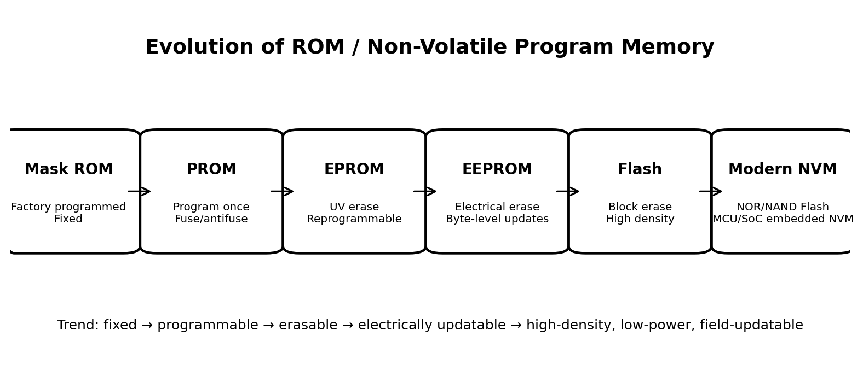
Figure 1. Major evolution of ROM-family technologies.

1. What is ROM?
ROM (Read-Only Memory) is a class of non-volatile semiconductor memory designed to retain information when electrical power is removed. The term originally described memory whose contents were fixed or could only be programmed in limited ways. In modern systems, the term is often used broadly for non-volatile program memory, even though many devices called “ROM” are actually Flash or EEPROM technologies.
The main reason ROM-family memory exists is persistence: firmware, boot code, device configuration, calibration constants, identifiers and other information must survive a power cycle. Modern microcontrollers commonly use Program Flash for executable code and may also include separate Data EEPROM for small, frequently updated non-volatile data.

2. Why was ROM needed?
Early computer systems needed a way to preserve instructions without depending on continuous power. Volatile working memory could not retain a program after shutdown. ROM provided a stable source of instructions that could be read whenever the system started.
A typical boot concept is:
- Power applied → processor reset
- Processor begins from a defined reset/boot location
- Firmware initializes hardware
- Firmware locates or starts the next boot stage
- Operating system/application code is loaded and executed

3. Traditional Mask ROM
Mask ROM is programmed during semiconductor manufacturing. The information is built into the device through the fabrication/mask process, so the customer cannot normally rewrite it.
Advantages: very low cost per device at high volume, excellent retention, and predictable behavior. Disadvantages: changing firmware requires a new mask/device revision, creating high non-recurring engineering cost and poor flexibility.
This made mask ROM suitable when the software was stable and production quantities were large. Microchip describes ROM as the least expensive program-memory option when code is stable and volumes are high.

4. PROM — Programmable ROM
PROM allowed the manufacturer or user to program the device after fabrication, normally once. A programming operation permanently changes fuse or antifuse structures. Once programmed, the contents cannot normally be changed.
This was a major improvement over mask ROM because firmware could be finalized after the chip was manufactured. The trade-off was that an error meant replacing the device. Early semiconductor PROMs used fuse links that were permanently changed by programming.

5. EPROM — Erasable Programmable ROM
EPROM introduced a major conceptual change: the memory could be erased and programmed again. EPROM cells used floating-gate MOSFET structures. Ultraviolet light passing through a quartz window could erase the stored charge, after which the chip could be reprogrammed.
The floating-gate concept was an important foundation for later electrically erasable memories. EPROM became especially valuable during firmware development because engineers could reuse the same device rather than discard it after every programming cycle.

6. EEPROM — Electrically Erasable PROM
EEPROM removed the need for UV light. The stored charge could be changed electrically, allowing the device to be erased and reprogrammed without physically removing it for UV exposure.
A key advantage is fine-grained updating: EEPROM can support byte-level alteration, making it useful for configuration, calibration, counters and small amounts of persistent data. Modern serial EEPROM devices are available over interfaces such as I²C and SPI and can support very high write endurance depending on the device.

7. Flash Memory — the major modern transition
Flash is a non-volatile memory technology derived from the electrically erasable floating-gate family. Its defining practical advantage is that it is optimized for higher density and block/sector-based erase operations rather than treating every byte as an independent erase unit.
This makes Flash particularly effective for storing firmware and larger data sets. NOR Flash is commonly used where fast random reads and firmware execution are important, while NAND Flash is optimized for high-density storage such as SSDs and removable storage.
Modern Flash therefore changed ROM from a mostly fixed firmware container into something that can be updated repeatedly, often while installed in the product.

8. What physically changed in the memory cell?
The major technological shift was from hard-wired/fuse-based representations toward transistor-based non-volatile cells. Floating-gate MOSFETs introduced a way to store electrical charge in an electrically isolated gate. The presence or absence of stored charge changes the transistor's electrical behavior, allowing the memory controller to interpret it as a stored state.
Later Flash generations improved density, erase/program mechanisms, array organization, interfaces and manufacturing processes. Some modern non-volatile memories also use charge-trap structures rather than the classic floating-gate implementation.
At the system level, this evolution changed the question from “Can the memory retain this code?” to “How efficiently, densely, securely and repeatedly can we retain and update this code?”

9. Why Flash became so important
- Field firmware updates: devices can receive new firmware without replacing the memory chip.
- Higher density: large amounts of firmware and data can be stored economically.
- Small packages: serial Flash and embedded Flash reduce board space.
- Lower power: modern non-volatile memory can retain data without continuous refresh power.
- Fast development: firmware can be repeatedly programmed during development.
- Product longevity: bugs and features can be addressed after deployment.
- Embedded integration: many MCUs include program Flash directly on the chip.
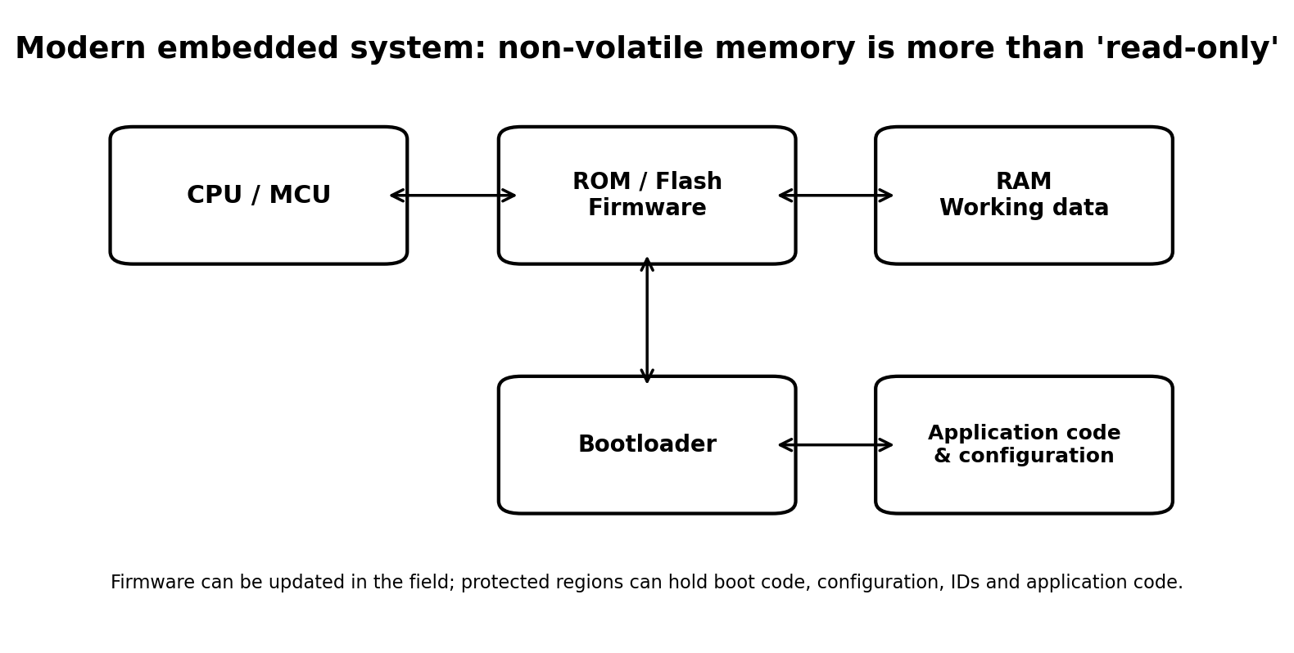
Figure 2. Example modern embedded-memory organization.

10. ROM in a modern microcontroller
Modern microcontrollers often contain several memory technologies rather than one generic “ROM.” For example, a device may contain Program Flash for executable firmware, SRAM for volatile working data, and EEPROM/Data Flash for persistent configuration. Microchip documents this separation explicitly for modern MCUs.
Program Flash may be divided into application, boot and storage areas. Some MCUs also provide code protection, write protection, CRC-on-boot verification and self-programming capabilities. These features are especially useful for field-updatable firmware and safety/security-sensitive systems.

11. ROM/Flash and booting
A simplified embedded boot sequence is:
- Reset
- Boot ROM / bootloader starts
- Hardware and memory are initialized
- Firmware image is located and verified
- Application firmware begins execution
- Runtime data is held in RAM
This distinction is important: the non-volatile memory preserves the firmware across power cycles, while RAM provides the volatile working area used during execution.

12. Technology comparison
Technology | Programmable after manufacture? | Reusable? | Erase method | Typical role | Flexibility | Key limitation
Mask ROM | No | No | Not normally erasable | High-volume fixed firmware | Very low | Cannot update
PROM | Yes, once | No | Permanent programming | Fixed production code | Low | One-time
EPROM | Yes | Yes | UV light | Development/legacy firmware | Medium | UV erase; package constraints
EEPROM | Yes | Yes | Electrical | Configuration/small persistent data | High | Lower density; write/erase limits
Flash | Yes | Yes | Electrical, usually block/sector | Firmware + mass storage | Very high | Erase granularity/endurance management

13. Important terminology: “ROM” vs “non-volatile memory”
In modern technical discussions, it is better to distinguish the historical term ROM from the broader category of non-volatile memory (NVM). A Flash chip is writable and erasable, so calling it literally “read-only” can be misleading. Nevertheless, many system diagrams and specifications still use “ROM” or “ROM area” to refer to firmware/non-volatile program storage.
The practical lesson is: do not assume that every memory labeled ROM is physically mask ROM. Check the device architecture and datasheet to determine whether it is Mask ROM, OTP/PROM, EPROM, EEPROM, NOR Flash, NAND Flash, embedded Flash, or another NVM technology.

14. Benefits of the evolution — from a system designer's perspective
Benefit | What the evolution enabled
Manufacturing | Firmware can move closer to final production instead of being permanently fixed during chip fabrication.
Development | Engineers can repeatedly erase/program memory, dramatically simplifying testing and debugging.
Maintenance | Products can receive firmware updates after deployment.
Security | Modern devices can implement code/write protection and boot-time integrity checks.
Reliability | Non-volatile storage preserves firmware and configuration through power loss.
Miniaturization | Memory can be integrated into MCUs/SoCs, reducing external components.
Cost | High-density Flash provides economical storage for firmware and data.

15. Examples relevant to embedded systems and drones
In a flight controller or other embedded device, non-volatile program memory can hold the bootloader and flight-control firmware. Separate non-volatile areas may hold calibration or configuration values. During operation, the processor uses RAM for variables, buffers and runtime state. Modern MCUs can support field firmware updates, memory protection and integrity checks, which are useful for maintaining deployed embedded systems.

16. Key takeaways
- ROM began as genuinely fixed, non-volatile memory.
- PROM made post-manufacture programming possible, but only once.
- EPROM introduced reusable programming using UV erasure.
- EEPROM made erasure/reprogramming electrical and practical in-system.
- Flash optimized electrically erasable memory for higher density and block operations.
- Modern systems often use Flash rather than traditional ROM for firmware.
- Modern MCUs may combine Program Flash, EEPROM/Data Flash and SRAM.
- The fundamental benefit across the evolution is persistent information with progressively greater programmability, density, integration and field-updatability.

How ROM Retains Data When Power Is Removed
The most important property of ROM and other non-volatile memories is that the stored state does not depend on a continuously applied power supply. The exact physical mechanism depends on the technology. In some ROMs the information is built into the physical structure of the chip; in others it is represented by trapped electrical charge.
- Mask ROM — The bit pattern is created during semiconductor fabrication by the presence or absence of transistor connections, vias, or other fixed structures. There is no stored electrical charge that has to be maintained. The physical arrangement itself represents the 0/1 value, so removing power does not alter it.
- Fuse PROM — Each programmable bit contains a tiny fuse or fusible link. Programming sends enough current through selected links to permanently open them. The open or intact physical connection is the stored state. Because the fuse does not automatically reform when power is removed, the information remains.
- Antifuse PROM — An antifuse starts as a non-conducting structure and is permanently changed into a conducting connection during programming. The resulting physical connection remains after power is removed, so the programmed state is retained.
- EPROM — An EPROM cell uses a floating-gate MOS transistor. Programming places electrons onto an electrically isolated floating gate. The surrounding insulating layer prevents the charge from freely escaping. The trapped charge changes the transistor's threshold voltage, and the circuit interprets that electrical state as a stored bit. With no external power, the charge remains trapped, so the bit is retained.
- EEPROM — EEPROM also uses an electrically isolated floating-gate or related charge-storage structure. Electrical programming places charge on the storage element and electrical erase removes it. When power is removed, the insulating layer continues to isolate the stored charge, allowing the bit to remain.
- Flash — Flash uses a dense array of non-volatile charge-storage cells. A stored charge changes the electrical characteristics of a transistor, allowing the memory circuitry to distinguish programmed and erased states. The charge remains in the insulated cell after power is removed. Flash trades fine-grained erase capability for efficient block/sector operations, which enables high-density firmware and storage applications.

The Key Idea Behind Non-Volatility
RAM normally stores a state using circuits that require power to maintain the state. ROM-family technologies avoid that requirement by using a physical condition that remains stable without continuous power. For traditional ROM, the condition is part of the chip's physical structure. For floating-gate memories, the condition is trapped electrical charge. This is why a firmware image can remain stored in a device even after it has been switched off for a long period.

What Changed Across the Generations?
Generation | Storage mechanism | What improved | Main limitation
Mask ROM | Fixed transistor/interconnect pattern | Low cost at high volume; permanent | Cannot be changed after manufacture
PROM | Fuse/antifuse state | User/manufacturer can program after fabrication | Usually one-time programming
EPROM | Floating-gate charge | Can be erased and reused | UV erasure; inconvenient for field updates
EEPROM | Electrically stored charge | Electrical erase/rewrite; fine-grained updates | Lower density and slower erase/write than Flash
Flash | Dense non-volatile cell array | High density, fast reads, block erase, field updates | Limited program/erase endurance; block-based erase

